RTL to GDSII - 5 Days Workshop

Report Submitted to

# Pandit Deendayal Energy University, Gandhinagar



Bachelor of Technology

*in*

# Information and Communication Technology Department

Submitted by

**Tapan Alpeshkumar Patel (23BIT158)**

**Division – 3 (H8)**

Submitted To:

## **Dr. Dhaval Pujara Sir, Dr. Puneet Mittal Sir,**

## **Dr. Arpan Desai Sir, Dr. Ankur Changela Sir, and Dr. Gunjan Thakur Ma’am.**

Department of Information Communication and Technology

School of Technology

**Acknowledgement**

I would like to express my sincere gratitude to **Pandit Deendayal Energy University** for providing me with the opportunity and resources to undertake this project as a part of my academic curriculum. This project has been an invaluable learning experience in the domain of digital design and hardware description languages.

I am deeply thankful to my project guide **Puneet Mittal Sir** for his valuable guidance, continuous support, and constructive feedback throughout the course of this project. His insights and expertise have been instrumental in shaping the direction and success of this work.

I extend my heartfelt thanks to **Dr. Dhaval Pujara Sir**, Director, for organizing and facilitating this project initiative and providing us with a platform to explore real-world design concepts.

I would also like to acknowledge the dedicated support and coordination provided by our faculty coordinators — **Dr. Arpan Desai Sir**, **Dr. Ankur Changela Sir**, and **Dr. Gunjan Thakur Ma’am**. Their consistent encouragement and timely mentorship played a key role throughout the project.

My appreciation also goes to the faculty members and technical staff of the **Information and Communication Technology / Electronics and Communication** department for their assistance and motivation during the project period.

I am thankful to **Synopsys** for granting access to their industry-standard EDA tools, which were vital in implementing and verifying various stages of the digital design process. The practical exposure to these tools has significantly strengthened my understanding of the RTL to GDSII flow.

Lastly, I would like to thank my family and peers for their constant encouragement, support, and motivation throughout this endeavor.

**Abstract**

This project report documents the complete physical design flow from Register Transfer Level (RTL) to GDSII, implemented using industry-standard Electronic Design Automation (EDA) tools from Synopsys. The RTL to GDSII flow is a fundamental phase in the VLSI (Very-Large-Scale Integration) design cycle, where high-level behavioral descriptions written in a Hardware Description Language (HDL) like Verilog are transformed into a physical layout ready for fabrication.

The report outlines each critical stage of the backend process, including logic synthesis, floorplanning, placement, clock tree synthesis (CTS), routing, and physical verification. These stages collectively ensure that the design meets timing, power, and area constraints while being functionally and physically correct.

The objective of the project was to gain hands-on experience in the digital backend design process and understand the challenges involved in converting RTL code into a silicon-ready layout. By working through a complete design flow, this project bridges theoretical VLSI concepts with industry-relevant practical skills, providing a deeper understanding of the RTL to tape-out process.

**Introduction**

VLSI (Very-Large-Scale Integration) design is the process of creating integrated circuits by combining thousands to millions of transistors onto a single chip. It plays a crucial role in the development of modern electronic devices, from smartphones to computers and automotive systems. As technology advances, the need for efficient and optimized chip designs becomes even more important.

One of the most critical parts of the VLSI design cycle is the **RTL to GDSII flow**. This process involves converting high-level digital logic, described using a hardware description language like Verilog, into a physical layout that can be manufactured. It includes several backend steps like synthesis, floorplanning, placement, clock tree synthesis, routing, and physical verification. Understanding this flow helps bridge the gap between theoretical design and real-world chip fabrication.

The main objective of this project was to gain hands-on experience with the RTL to GDSII flow using industry-grade tools and to understand how a digital design evolves through each backend stage. It provided practical exposure to how chip layouts are created and prepared for tape-out.

To carry out this project, we used **Synopsys EDA tools**, which are widely used in the semiconductor industry. These tools enabled us to implement, verify, and analyze the physical design process with accuracy and efficiency. Working with Synopsys software gave us valuable insight into how professional digital ICs are developed in real-world scenarios.

### Literature Review / Background

#### **RTL Design and Hardware Description Languages**

Register Transfer Level (RTL) design is a high-level abstraction used in digital circuit design where the behavior of a system is described in terms of data flow between registers. At this stage, designers focus on the functional logic without worrying about physical implementation. RTL design is commonly written using Hardware Description Languages (HDLs) such as **Verilog** or **VHDL**.

**Verilog** is widely used in industry and academia for modeling digital systems. It allows designers to describe the structure and behavior of digital circuits, simulate their functionality, and verify that they meet design specifications before moving on to the physical design stage.

#### **Physical Design Concepts**

Physical design is the process of converting the synthesized RTL design into a geometric representation that can be fabricated on silicon. It involves several key steps:

* **Synthesis** – Converts RTL code into a gate-level netlist using logic gates and standard cells.
* **Floorplanning** – Defines the placement of major blocks and I/O pins on the chip.
* **Placement** – Arranges standard cells on the silicon area to minimize area, power, and delay.
* **Clock Tree Synthesis (CTS)** – Distributes the clock signal across the chip to minimize skew and latency.
* **Routing** – Connects all placed cells according to the netlist using metal layers.
* **Physical Verification** – Ensures the design meets manufacturing rules using checks like DRC (Design Rule Check) and LVS (Layout vs Schematic).

These steps together ensure the chip is physically correct, functionally valid, and ready for tape-out.

#### **Tools Used in Industry (Focus on Synopsys Suite)**

In the semiconductor industry, several EDA (Electronic Design Automation) tools are used for backend VLSI design. **Synopsys** is a leading provider of these tools, offering a comprehensive suite for physical design, verification, and timing analysis.

Key Synopsys tools used in this project include:

* **Design Compiler** – for RTL synthesis to generate gate-level netlists.
* **IC Compiler II** – for the complete physical design flow including floorplanning, placement, CTS, and routing.
* **PrimeTime** – for static timing analysis and timing closure.
* **VCS or ModelSim** – for simulation and functional verification of Verilog code.
* **DRC/LVS Tools** – for physical verification to ensure manufacturability.

Using these tools provides a professional-level experience and deepens the understanding of real-world chip design workflows.

### First 5 Days of Project Work: Full Adder Circuit Implementation

**RTL Design, Simulation, and Synthesis of a Full Adder using Verilog and Synopsys Tools**

* **Full Adder Circuit Design:**

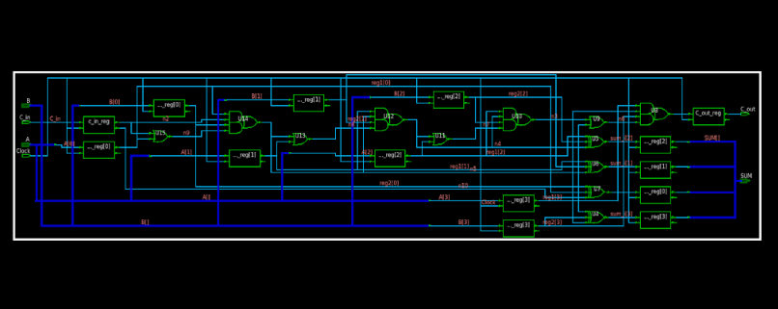

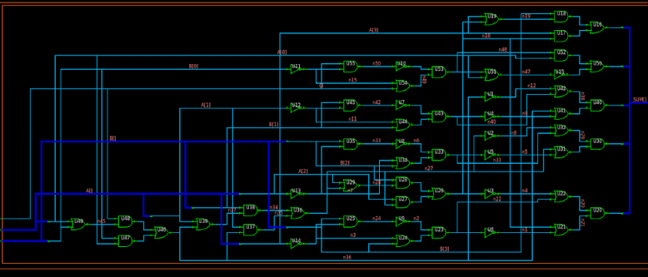

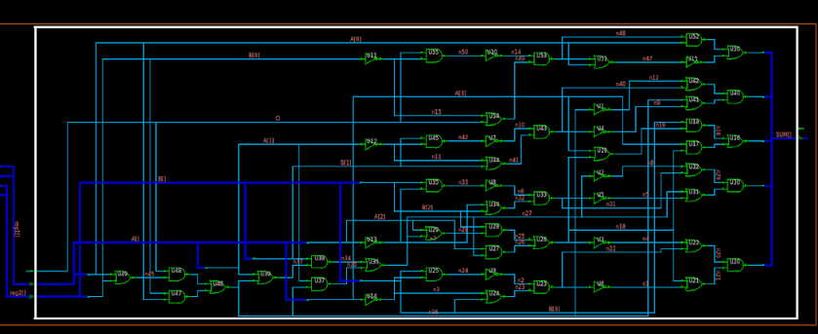

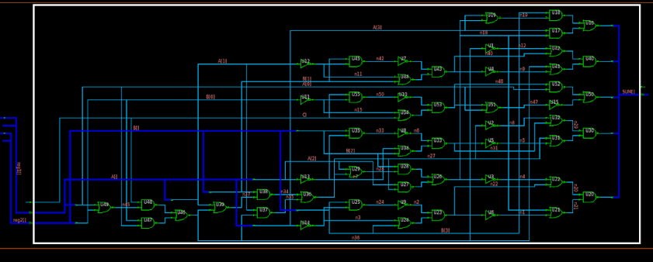

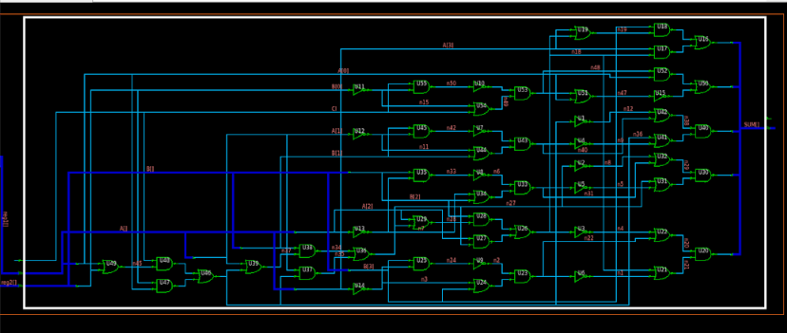

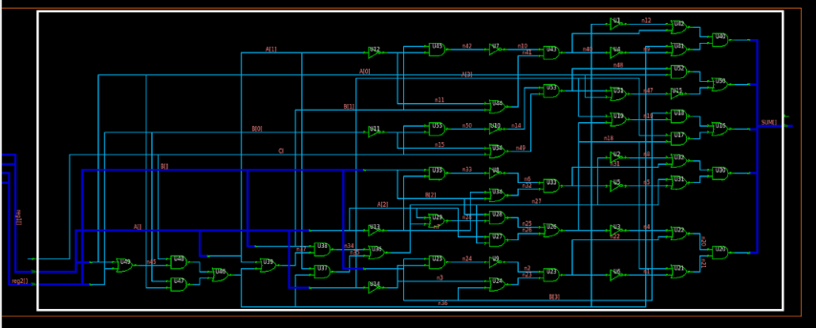

* Different Scenarios :
* Scenario 1:

Floor Planning: Power Planning:

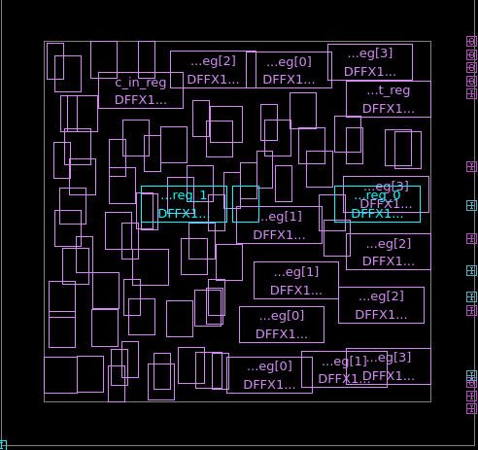 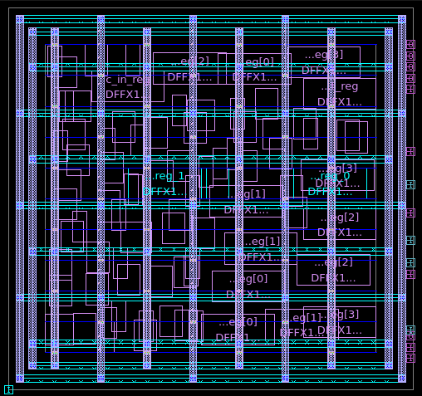

Placement: Clock:

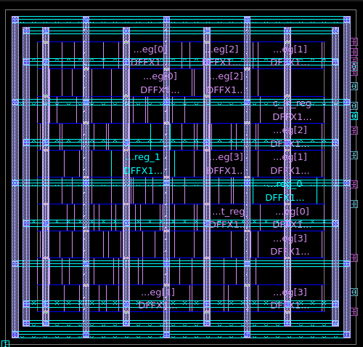 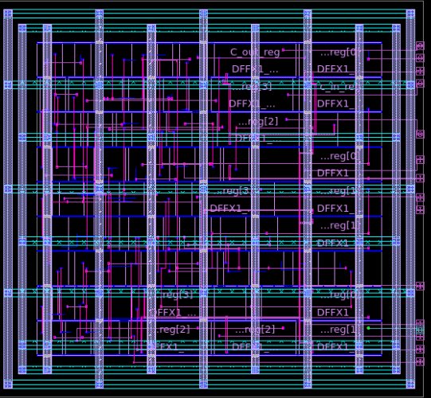

Route:

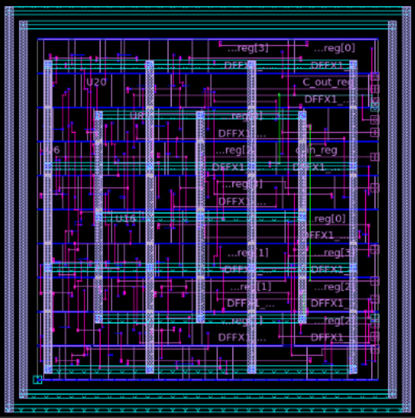

* Scenario 2:

Floor Planning: Power Planning:

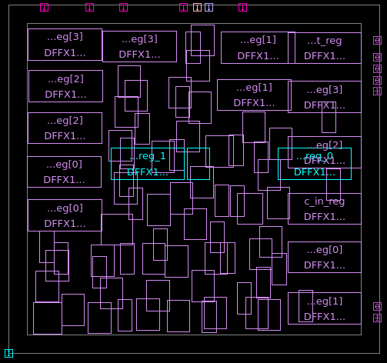 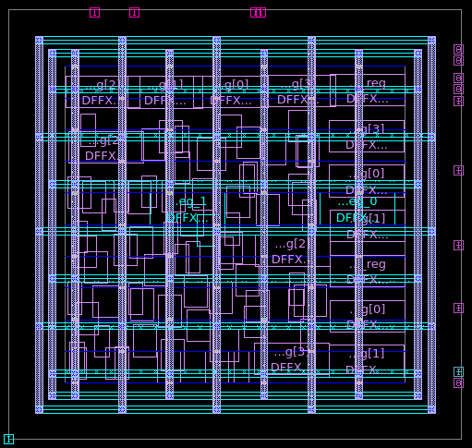

Placement: Clock:

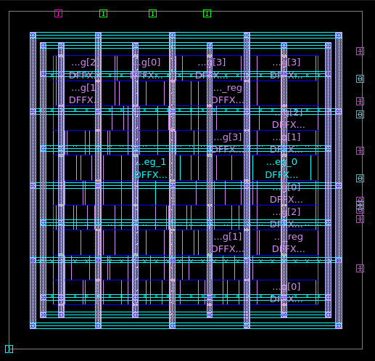 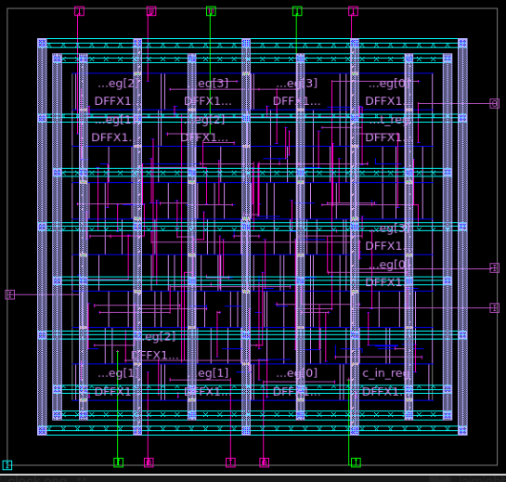

Route:

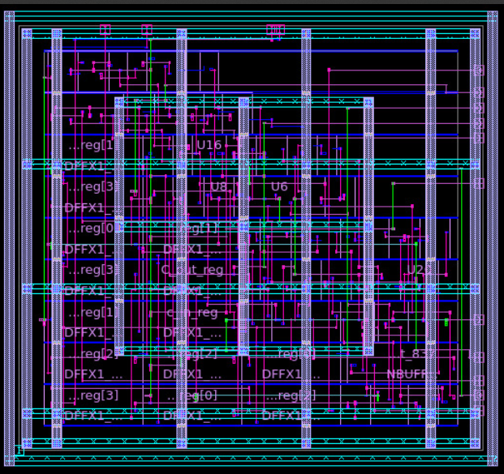

* Scenario 3:

Floor Planning: Power Planning:

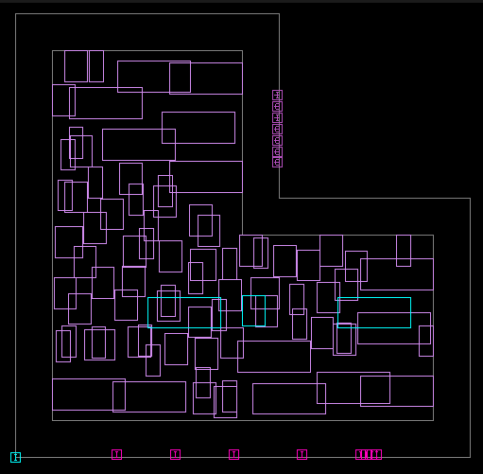 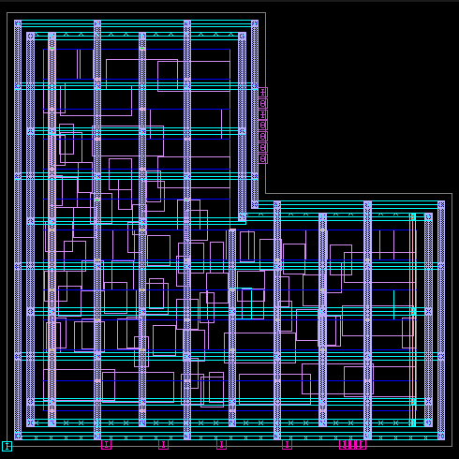

Placement: Clock:

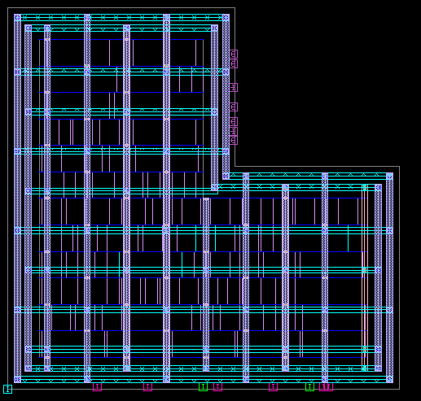 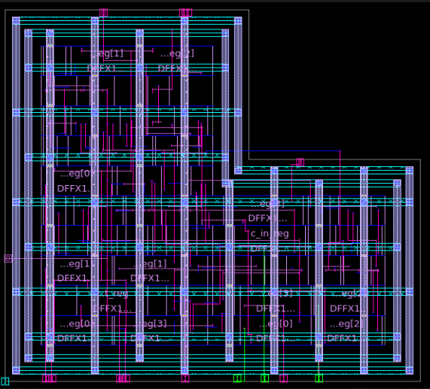

Route:

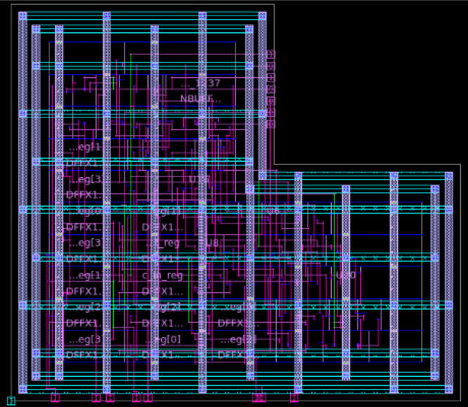

* Scenario 4:

Floor Planning: Power Planning:

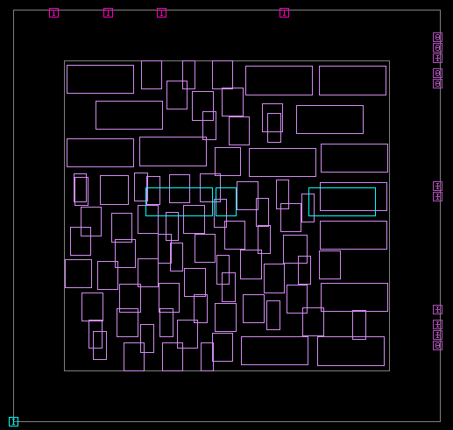 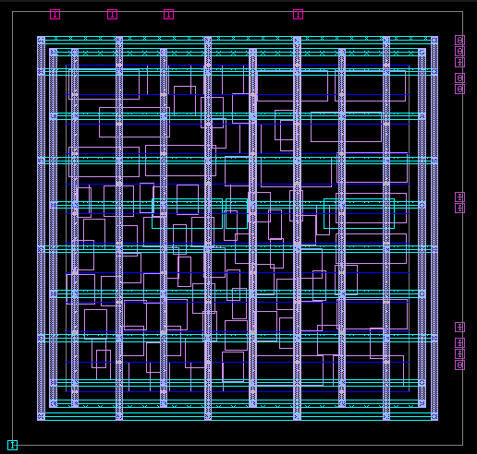

Placement: Clock:

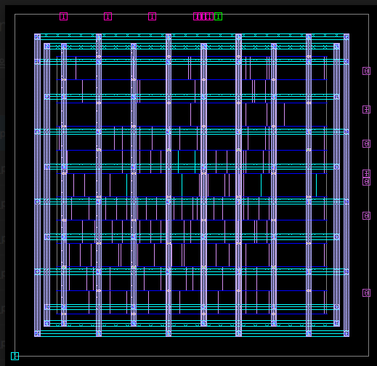 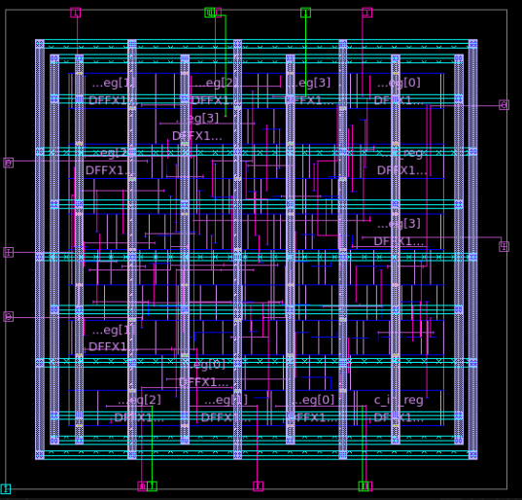

Route:

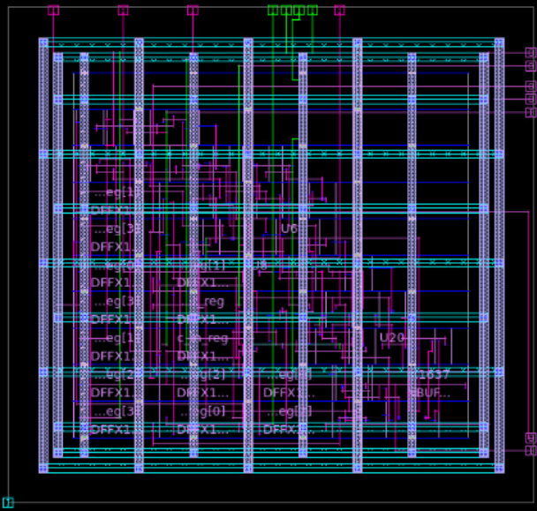

* Scenario 5:

Floor Planning: Power Planning:

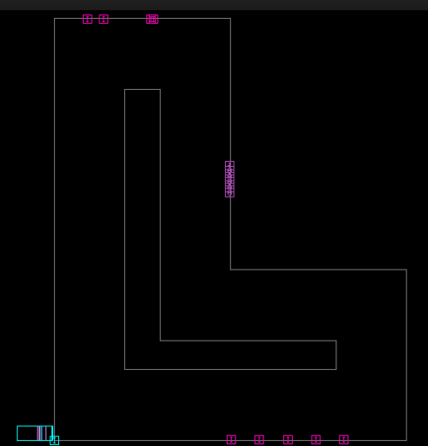 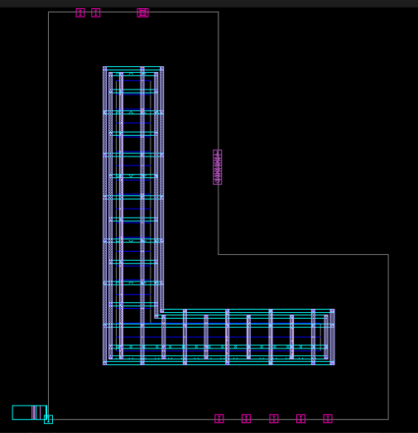

Placement: Clock:

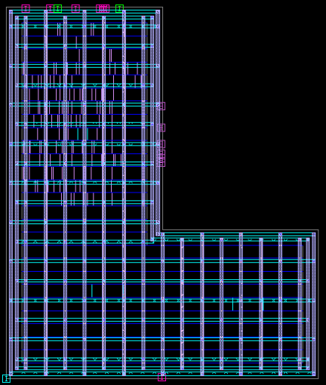 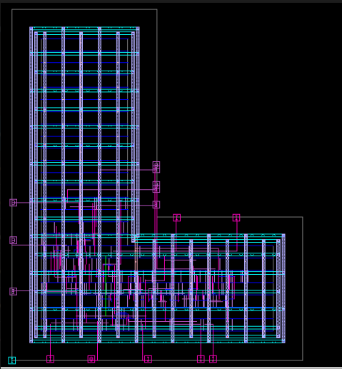

Route:

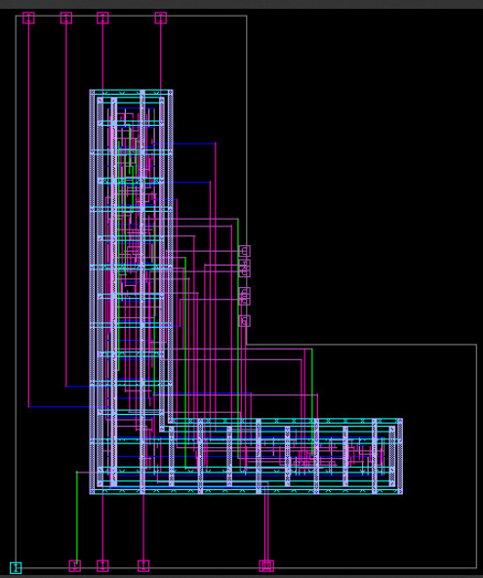

* Scenario 6:

Floor Planning: Power Planning:

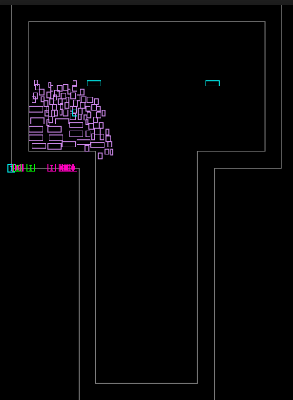 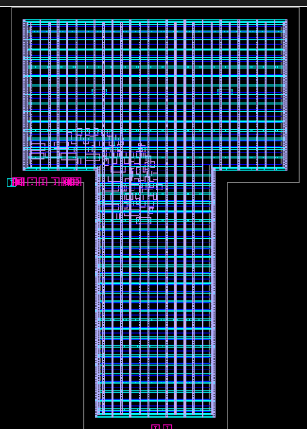

Placement: Clock:

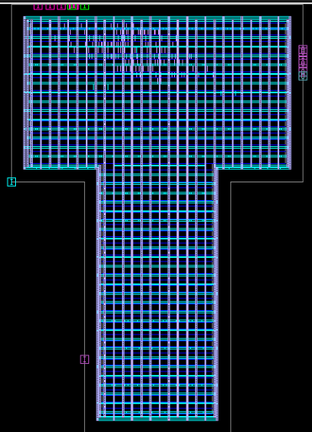 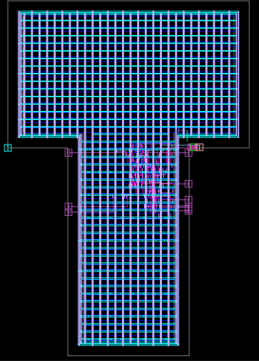

Route:

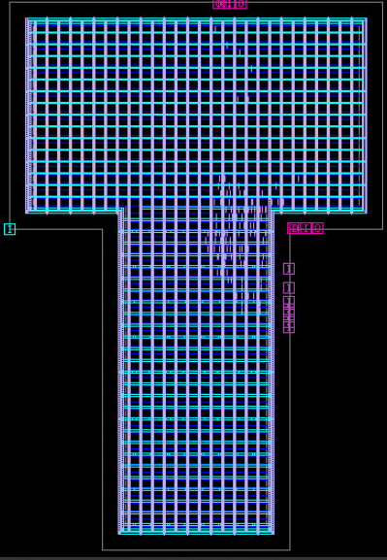

* Scenario 7:

Floor Planning: Power Planning:

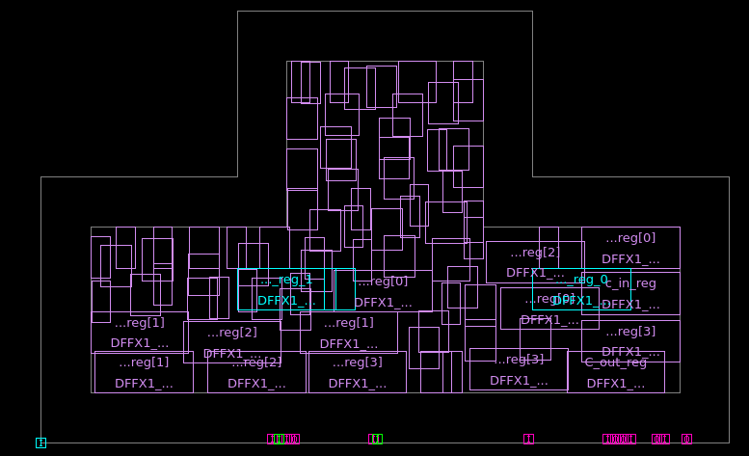 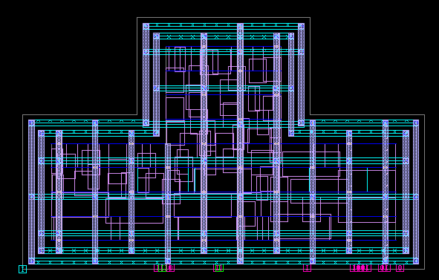

Placement: Clock:

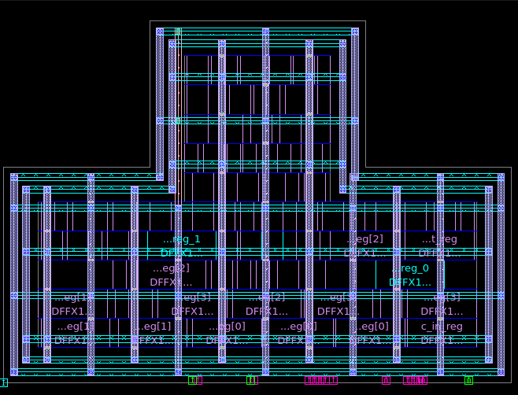 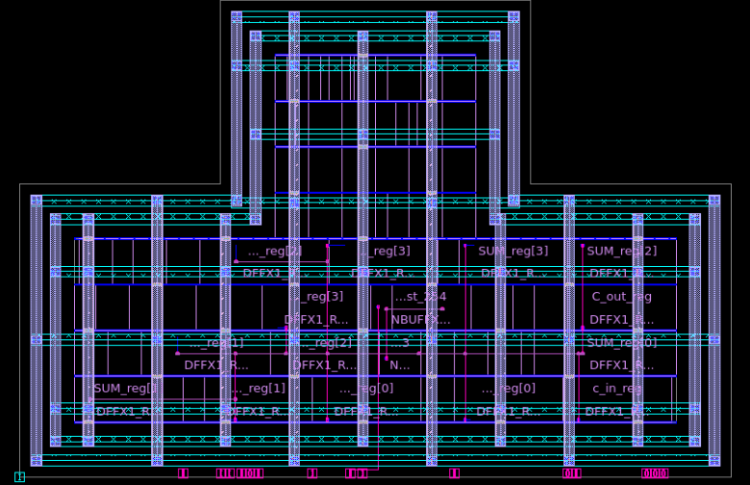

Route:

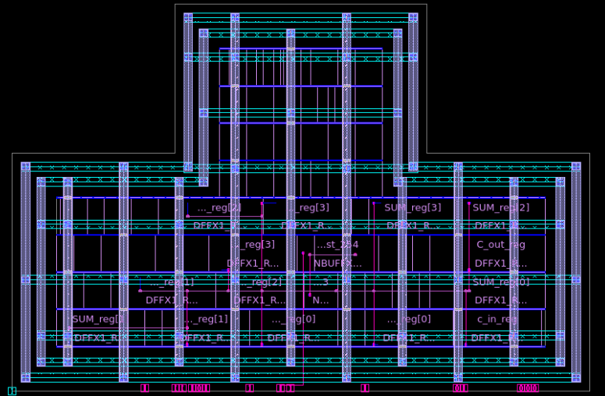

* Scenario 8:

Floor Planning: Power Planning:

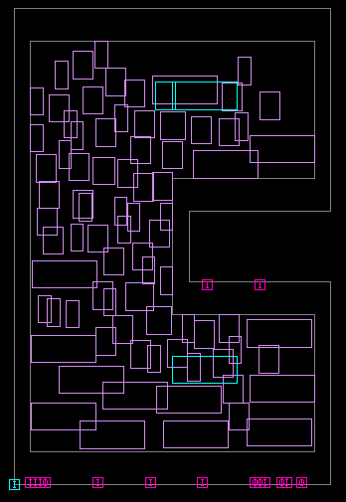 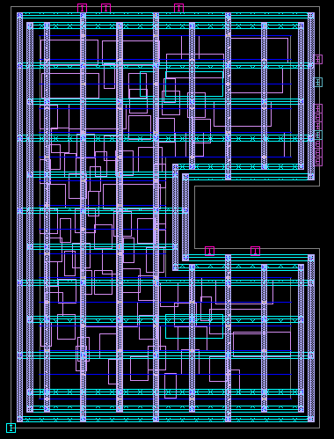

Placement: Clock:

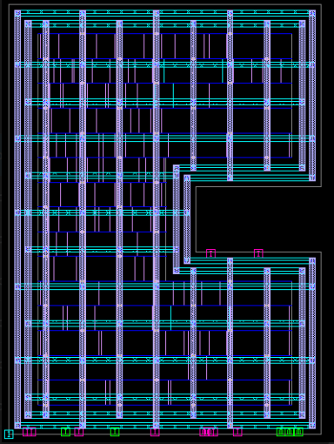 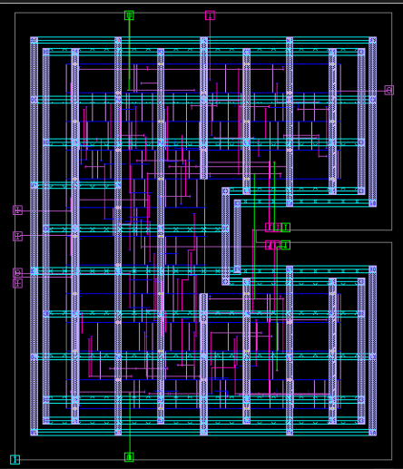

Route:

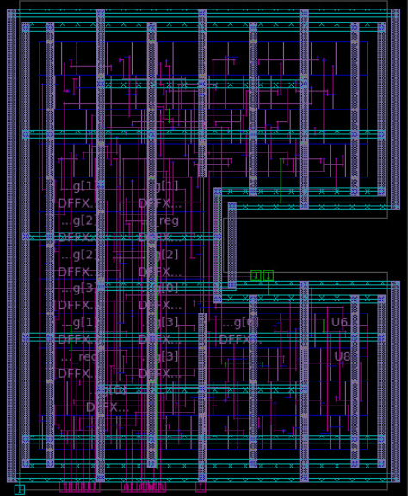

* Scenario 9:

Floor Planning: Power Planning:

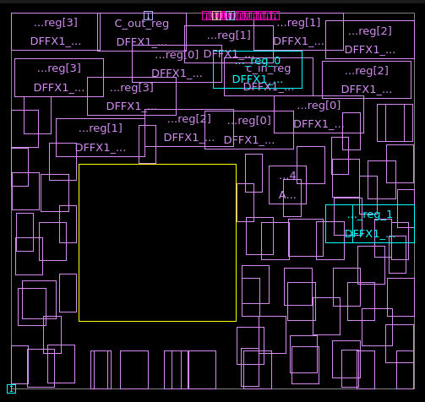 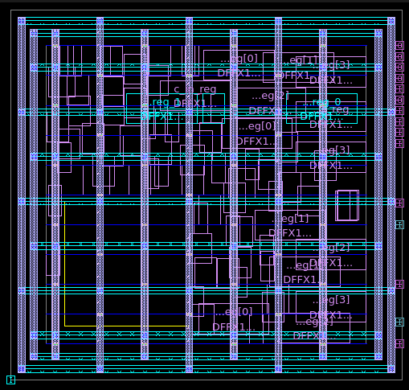

Placement: Clock:

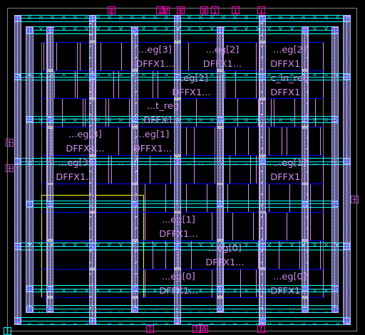 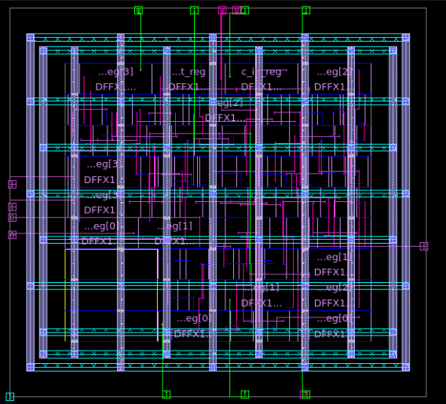

Route:



* Scenario 10:

Floor Planning: Power Planning:

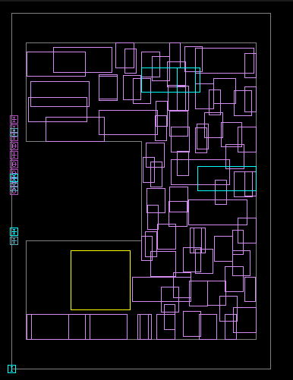 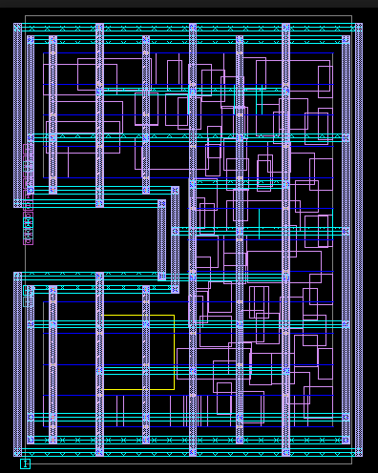

Placement: Clock:

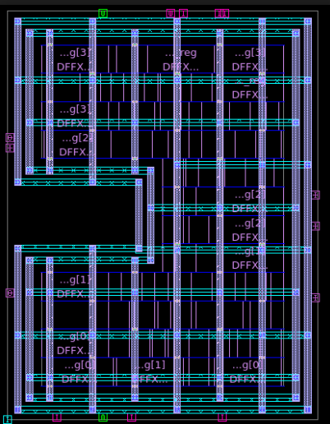 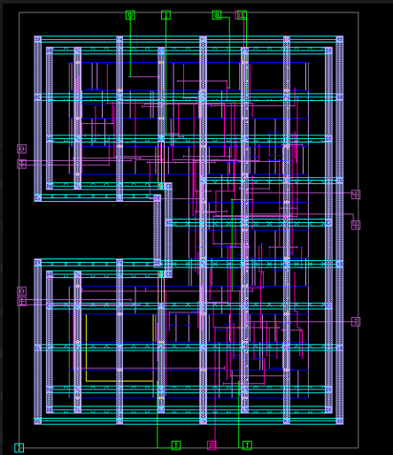

Route:

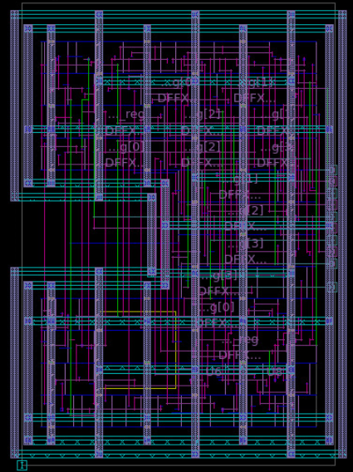

**RTL Synthesis and Static Timing Analysis:  
Design Implementation, Constraints, and Reports using Synopsys Design Compiler**

1. **Initial Conditions:**

|  |  |
| --- | --- |
| **Constraint** | **Value** |
| Clock period | 1.1 ns |
| Input maximum delay | 0.5 ns |
| Output maximum delay | 0.5 ns |
| Input transition time | 0.5 ns |
| Setup uncertainty | 0.300 ns |
| Hold uncertainty | 0.100 ns |
| Max transition (data path) | 0.250 ns |
| Max transition (clock path) | 0.150 ns |

|  |  |
| --- | --- |
| **Parameter** | **Value** |
| Synthesis Tool | Synopsys Design Compiler |
| Synthesis Method | compile_ultra |
| Design Library | WORK |
| RTL Source File | sub_8bit_rtl.v |
| Constraints File | 8bit_sub.sdc |
| Library Used | saed32rvt_tt0p78vn40c.db |

|  |  |
| --- | --- |
| **Component** | **Description** |
| saed32rvt | SAED 32nm Regular-Vt standard cell library |
| Tt | Typical-Typical process corner |
| 0p78v | Supply voltage = 0.78V |
| n40c | Nominal operating temperature = 40°C |

|  |  |
| --- | --- |
| **Cell Pattern (set_don’t_use)** | **Cell Type Description** |
| */FADD* | Full Adders |
| */AO* | AND-OR gates |
| */NAND* | NAND gates |
| */NOR* | NOR gates |
| */MUX* | Multiplexers |

1. **RTL and TESTBENCH Code Snippets:**

**sub_8bit_rtl.v (RTL) :**

module subtractor_8bit (

input clk,

input [7:0] a,

input [7:0] b,

output reg [7:0] result

);

reg [7:0] a_reg, b_reg;

reg [3:0] count = 0;

always @(posedge clk) begin

if (count == 0) begin

a_reg <= a;

b_reg <= b;

end

if (count == 7) begin

result <= $signed(a_reg) - $signed(b_reg);

count <= 0; // Reset for next operation

end else begin

count <= count + 1;

end

end

endmodule

**sub_8bit_tb.v (Testbench):**

`timescale 1ns / 1ps

`include "sub_8bit_rtl.v"

module testbench;

reg clk;

reg [7:0] a, b;

wire [7:0] result;

// Instantiate the subtractor

subtractor_8bit uut (

.clk(clk),

.a(a),

.b(b),

.result(result)

);

// Generate clock: 10ns period

always #5 clk = ~clk;

initial begin

$fsdbDumpvars();

clk = 0;

// Test 1: 100 - 25 = 75

a = 8'd100; b = 8'd25;

#90; // 8+1 cycles

$display("Test 1: %d - %d = %d", $signed(a), $signed(b), $signed(result));

// Test 2: 50 - 100 = -50

a = 8'd50; b = 8'd100;

#90; $display("Test 2: %d - %d = %d", $signed(a), $signed(b), $signed(result));

// Test 3: -30 - 20 = -50

a = -8'sd30; b = 8'd20;

#90;

$display("Test 3: %d - %d = %d", $signed(a), $signed(b), $signed(result));

$finish;

end

endmodule

**RTL Design Verification:**

After writing the RTL code and its corresponding testbench, the first step is to compile and simulate the design to verify its functional correctness. This is done using a simulation tool where the testbench applies stimulus to the RTL and checks the output behavior. Once the design passes functional simulation, it is taken to the synthesis phase using a tool like **dc_shell** (Design Compiler). In this step, the RTL is translated into a gate-level netlist using technology-specific standard cells. Constraints such as timing, area, and power are applied to guide the synthesis process. The output of synthesis includes the gate-level netlist, along with reports on area, timing, and power, which serve as inputs for the subsequent physical design stage.

**Key DC Shell Report Summary:**

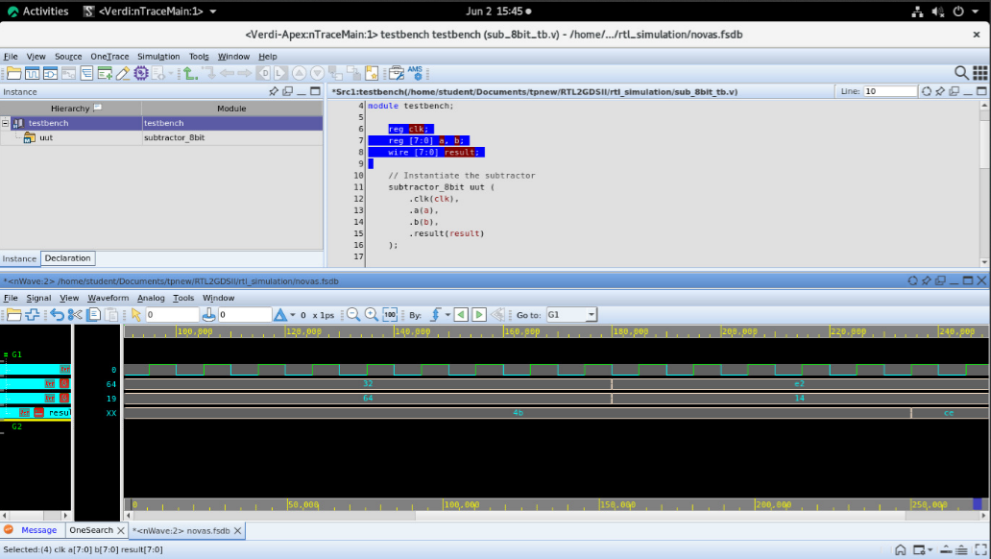

| **Parameter** | **Value** |
| --- | --- |
| **Slack (MET)** | 0.50 ns |
| **Total Dynamic Power** | 0.6617 µW |
| **Cell Area** | 0.0000 (units) |
| **Total Design Area** | 72.41 (units) |
| **Leaf Cell Count** | 66 |
| **Combinational Cell Count** | 40 |
| **Sequential Cell Count** | 26 |
| **Number of Nets** | 106 |
| **Number of Hold Violations** | 9 |

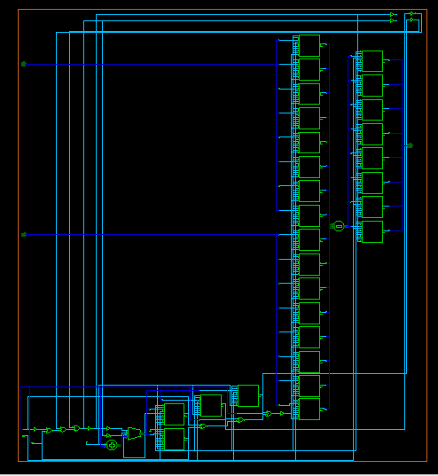

**Key ICC_2 Shell Report Summary:**

1. **Floorplanning:**

In the floorplanning stage, the physical layout of the chip is initialized. This involves defining the core and die area, placing input/output (I/O) pads, and allocating space for major functional blocks. It also includes setting placement constraints and planning for power distribution, ensuring an efficient layout for routing and timing optimization.

**3rd Scenario:**

initialize_floorplan -shape L -core_offset 2 -coincident_boundary true

set_individual_pin_constraints -ports [get_ports {A B}] -sides 6

place_pins -self

create_placement -floorplan -effort medium

| **Parameter** | **Value** |
| --- | --- |
| **Slack (MET)** | 0.33 ns |
| **Critical Path Length** | 0.50 ns |
| **Clock Period** | 1.10 ns |
| **Leaf Cell Count** | 109 |
| **Combinational Cells** | 83 |
| **Sequential Cells** | 26 |
| **Total Design Area** | 346.65 cell area units |
| **Total Nets** | 146 |
| **Total Dynamic Power** | 816 mW (8.16×10^8 pW) |
| **Cell Leakage Power** | 817 mW (8.17×10^8 pW) |

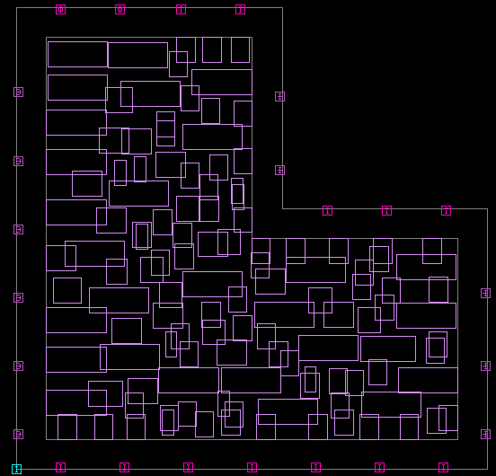

1. **Power_planning:**

In the power planning stage, a robust power distribution network (PDN) is created to ensure reliable power delivery across the chip. This includes inserting power and ground rings around the core, placing stripes within the core area, and connecting them to power pads. The goal is to minimize IR drop and ensure uniform voltage distribution to all cells.

| **Parameter** | **Value** |
| --- | --- |
| **Slack (MET)** | 0.33 ns |
| **Critical Path Length** | 0.50 ns |
| **Clock Period** | 1.10 ns |
| **Leaf Cell Count** | 109 |
| **Combinational Cells** | 83 |
| **Sequential Cells** | 26 |
| **Total Design Area** | 346.65 cell area units |
| **Total Nets** | 146 |
| **Total Dynamic Power** | 816 mW (8.16×10^8 pW) |
| **Cell Leakage Power** | 817 mW (8.17×10^8 pW) |

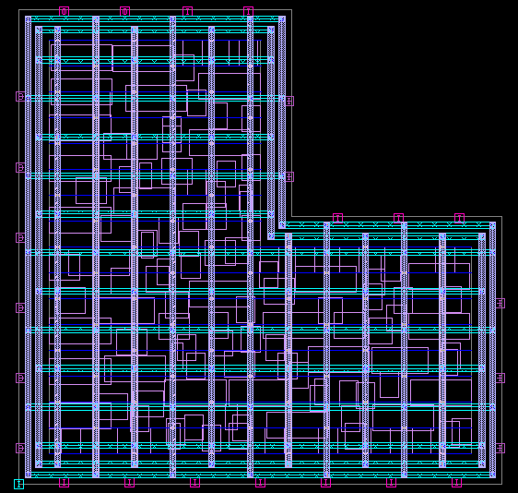

1. **Placement:**

In the placement stage, the standard cells are positioned within the floorplanned area without overlapping. The objective is to optimize timing, area, and routability. Clock tree synthesis (CTS) is also prepared in this stage to minimize skew and latency, and ensure signal integrity.

| **Parameter** | **Value** |
| --- | --- |
| **Slack (MET)** | 0.33 ns |
| **Critical Path Length** | 0.50 ns |
| **Clock Period** | 1.10 ns |
| **Leaf Cell Count** | 109 |
| **Combinational Cells** | 83 |
| **Sequential Cells** | 26 |
| **Total Design Area** | 346.65 cell area units |
| **Total Nets** | 146 |
| **Total Dynamic Power** | 816 mW (8.16×10^8 pW) |
| **Cell Leakage Power** | 817 mW (8.17×10^8 pW) |

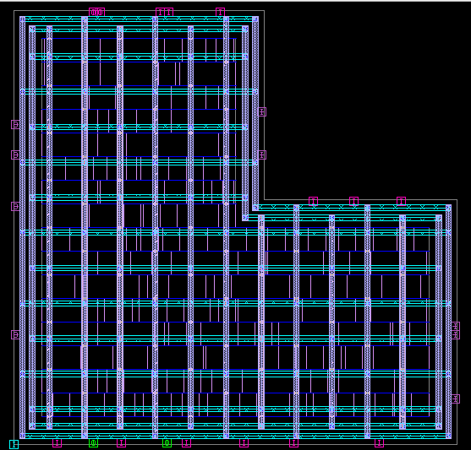

1. **Clock Synthesis:**

In the clock synthesis stage, also known as Clock Tree Synthesis (CTS), the clock network is built to distribute the clock signal from the clock source to all sequential elements (like flip-flops) in a balanced way. The goal is to minimize clock skew and latency, ensuring reliable and synchronized operation of the entire design.

| **Parameter** | **Value** |
| --- | --- |
| **Slack (MET)** | 0.24 ns |
| **Critical Path Length** | 0.50 ns |
| **Clock Period** | 1.10 ns |
| **Leaf Cell Count** | 109 |
| **Combinational Cells** | 83 |
| **Sequential Cells** | 26 |
| **Total Design Area** | 346.65 cell area units |
| **Total Nets** | 146 |
| **Total Dynamic Power** | 421 mW (4.21×10^8 pW) |
| **Cell Leakage Power** | 817 mW (8.17×10^8 pW) |

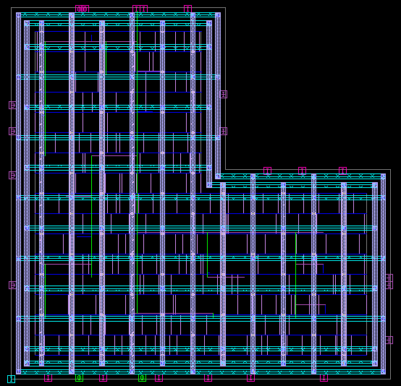

1. **Routing Stage:**

In the routing stage, physical connections (wires) are created between the placed standard cells according to the netlist. This includes both global routing (defining routing paths) and detailed routing (assigning exact tracks and layers). The aim is to meet timing, reduce congestion, and ensure signal integrity while obeying design rules.

| **Parameter** | **Value** |
| --- | --- |
| **Slack (MET)** | 0.24 ns |
| **Critical Path Length** | 0.50 ns |
| **Clock Period** | 1.10 ns |
| **Leaf Cell Count** | 109 |
| **Combinational Cells** | 83 |
| **Sequential Cells** | 26 |
| **Total Design Area** | 346.65 cell area units |
| **Total Nets** | 146 |
| **Nets with Violations** | 18 |
| **Max Transition Violations** | 18 |
| **Max Capacitance Violations** | 0 |
| **Net Length** | 1065.58 |
| **Net XLength** | 537.12 |
| **Net YLength** | 528.46 |
| **Total Dynamic Power** | 421.0 mW (4.21e+08 pW) |
| **Total Leackage Power** | 817.0 mW (8.17e+08 pW) |

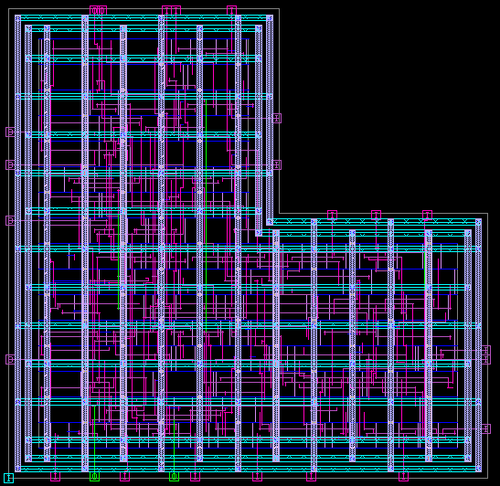

**Key PT_SHELL Report Summary:**

In the **PrimeTime (PT) Shell** stage, the design undergoes static timing analysis (STA) to verify that it meets timing constraints under different operating conditions. It checks timing paths such as input-to-register, register-to-register, and register-to-output, ensuring setup and hold time requirements are met. Power, area, and other QoR (Quality of Results) metrics are also analyzed to validate the final design before tape-out.

| **Parameter** | **Post-Route (Pre-PT)** | **Post-PT Shell** |
| --- | --- | --- |
| **Slack (Worst)** | 0.24 ns | 0.133652 ns |
| **Critical Path Delay** | 0.50 ns (in2reg) | 4.363878 ns |
| **Data Required Time** | 0.76 ns (in2reg) | 4.497530 ns |
| **Data Arrival Time** | 0.52 ns | 4.363878 ns |
| **Clock Period** | 1.10 ns | 5.00 ns |
| **Clock Uncertainty** | -0.10 ns | -0.402470 ns |
| **Setup Time** | -0.24 ns | -0.402470 ns (combined) |
| **Total Negative Slack (TNS)** | 0.00 | 0.00 |
| **Violating Paths** | 0 | 0 |
| **Combinational Cell Count** | 83 | 83 |
| **Sequential Cell Count** | 26 | 26 |
| **Leaf Cell Count** | 109 | 109 |
| **Buf/Inv Cell Count** | 30 | 30 |
| **Total Cell Area** | 346.65 µm² | 346.65 µm² |
| **Net Length (X + Y)** | ~1065.58 units | ~1065.58 units |
| **Dynamic Power** | 421.0 mW (4.21e+08 pW) | 421.0 mW (4.21e+08 pW) |
| **Leakage Power** | 817.0 mW (8.17e+08 pW) | 817.0 mW (8.17e+08 pW) |
| **Total Power** | 1.24 W (1.24e+09 pW) | 1.24 W (1.24e+09 pW) |
| **Max Transition Violations** | 18 | 18 |
| **Max Capacitance Violations** | 0 | 0 |

### ****Conclusion:****

Through this project, I got the chance to dive deep into the complete **RTL to GDSII flow**, which is one of the core parts of backend VLSI design. Starting from writing RTL code in Verilog to generating a final layout that's ready for fabrication, I experienced each stage hands-on using Synopsys tools.

In the **first 5 days**, I worked on designing and verifying a **full adder**. This helped me get comfortable with the Verilog coding style, simulation basics, and how synthesis transforms RTL into gate-level representation. It acted as a warm-up for the main project.

Later, as a major outcome of the workshop and the core focus of this project, I went ahead and designed an **8-bit subtractor**. This larger and more complex design allowed me to apply everything I had learned—from RTL simulation and synthesis to physical design, routing, and timing analysis.

One of the biggest takeaways was understanding how a design evolves through different stages like **synthesis, floorplanning, placement, CTS (Clock Tree Synthesis), routing, and timing analysis**. Each step added more detail and complexity, but also brought the design closer to reality.

In synthesis, I saw how our simple 8-bit subtractor design was converted into a gate-level netlist. The design met timing with a **slack of 0.50 ns**, and the initial area was just around **72.41 units**, which was pretty compact. As we moved into floorplanning and placement, the area naturally increased to about **346.65 units**, since now we had to physically place everything while also planning for power and routing.

I also observed how **power consumption increased** as the design matured. From around **0.66 µW** after synthesis, the total power went up to around **1.24 W** post-routing. This included both dynamic and leakage power. It made me realize how physical aspects like cell placement, clock networks, and routing paths contribute to power and area.

Clock Tree Synthesis was another interesting phase. Even though we managed to distribute the clock effectively, it slightly affected our slack, bringing it down to **0.24 ns**, which was still within limits. Finally, using PrimeTime, I checked the full timing again, and the slack was **0.133 ns**, showing that the design still held up well.

Working on 10 different design scenarios helped me experiment with different floorplans and observe their impact. While the basic logic remained the same, changes in placement, power grid layout, or pin assignments sometimes affected slack, area, or routing congestion.

Overall, this project helped me connect the **theoretical VLSI concepts** we’ve studied in class with real-world practices. I got comfortable using industry-grade tools like **Design Compiler, IC Compiler II, and PrimeTime**, and I learned that VLSI design isn’t just about writing code—it’s also about timing, power, layout, and making everything work together.

Most importantly, it gave me confidence to work on actual chip design problems and a clear idea of what goes into preparing a design for tape-out. It was a challenging but very rewarding experience.